Koby Miller

Section number: 11207

Assignment number: 2

Date due: 1/21/2020

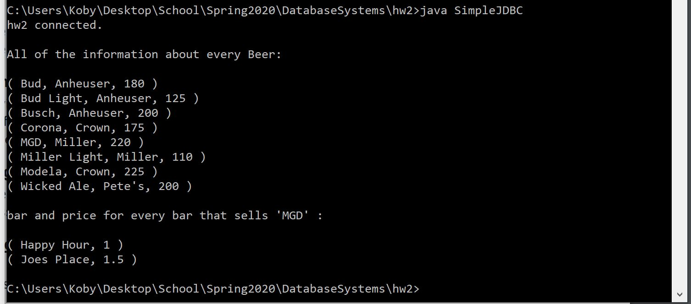

Queries used:

1. SELECT \* FROM Beers;
2. SELECT \* FROM sells WHERE beer = 'MGD';
   1. But in the Java I only printed out the bar and the price